**Task 4: Parallel Programming**

**Part 1: Third Program**

Opening the nano text editor via the terminal window, we wrote and saved the following program:

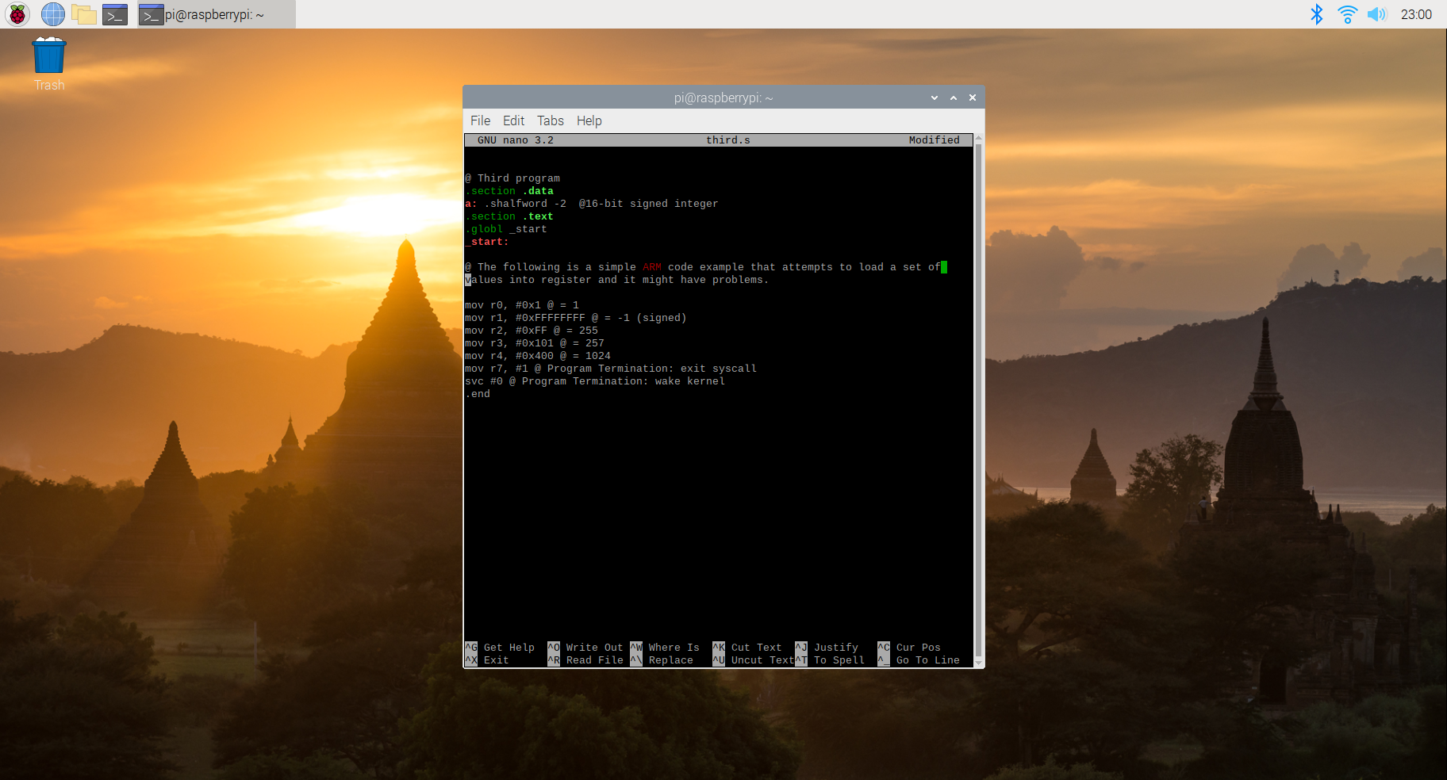

Error:

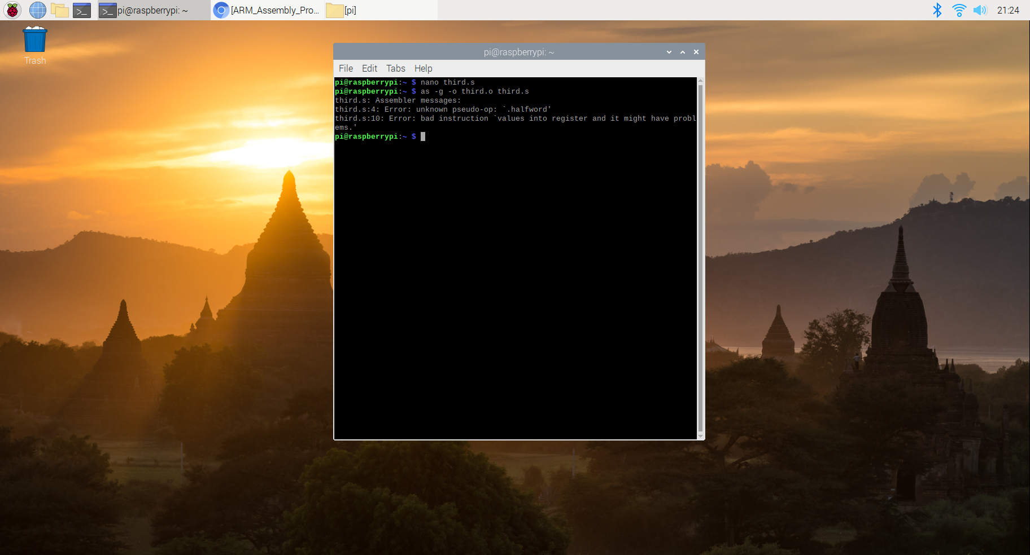

We change .shalfword to .hword because the Arm assembly does not recognize shalfword as a data type. We also add a comment tag before the comment of the second line to fix the comment error.

Modified code:

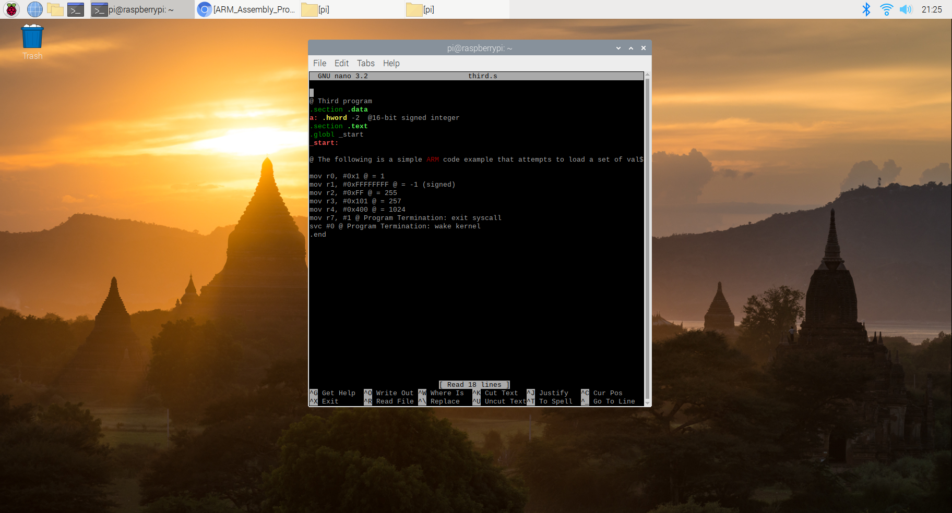

After composing the file, we then assembled and linked it in order the receive an executable file. Next, we utilized the GDB (GNU DeBugger) in order to get an idea on how our third was being executed. Preparing to use the GDB required us to re-assemble the program with an additional flag “-g”. No additional steps were needed when the program was re-linked. After the new executable was generated, we launched the GDB with the file name “third” which we wished for the debugger to examine.

To utilize the full functionality of the debugger, we needed to implement the additional step of setting a breakpoint. That allowed us to see how the program was completing its tasks. To stop the program prior to the execution of line 7, we gave the GDB the command “b 7”, and then we ran the program from its beginning until the breakpoint utilizing “run”. We were then able to execute the instructions step-by-step using the “stepi” command.

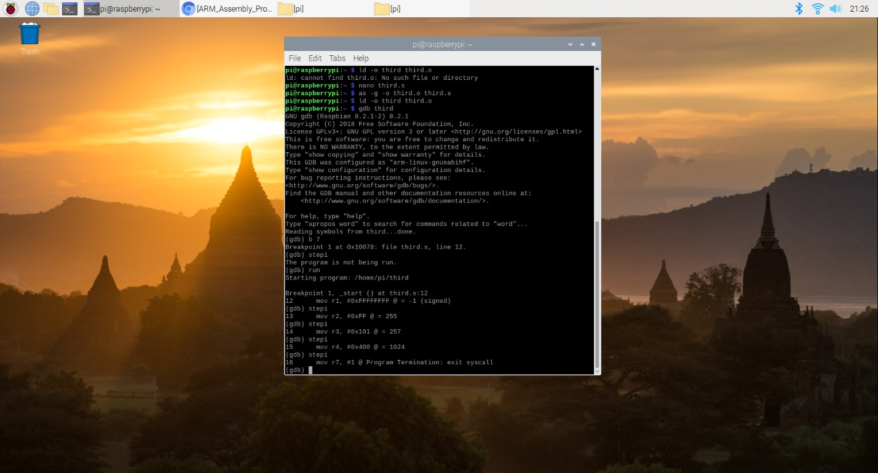

After the stepi function we used the command to examine one halfword in hexadecimal at the value the label a is pointing at.

If we use x/1xh it returns FFFE, which is -2 in hexadecimal

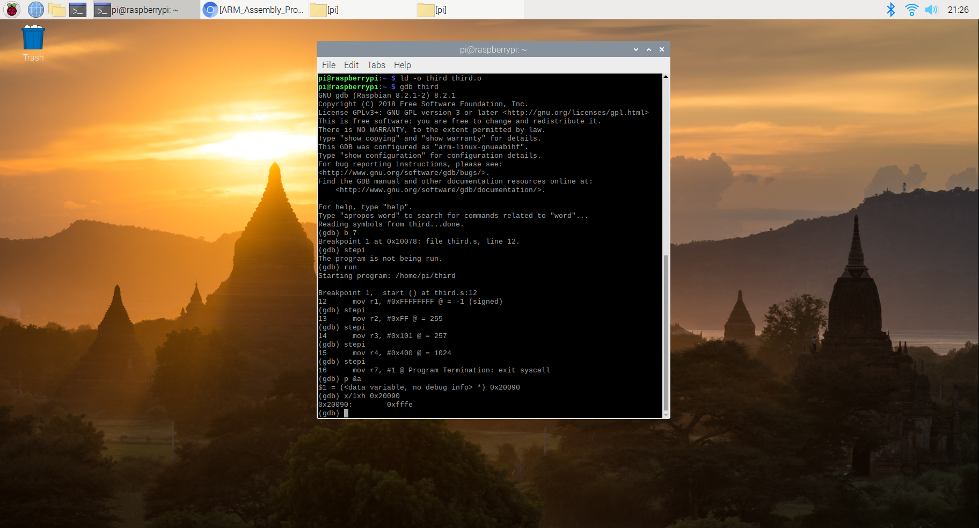

If we use x/1xsh it returns FFFE with an ASCII. We thought it is because the computer does not understand if we want to store a number or a string into the memory, so it returns an ASCII after the value.

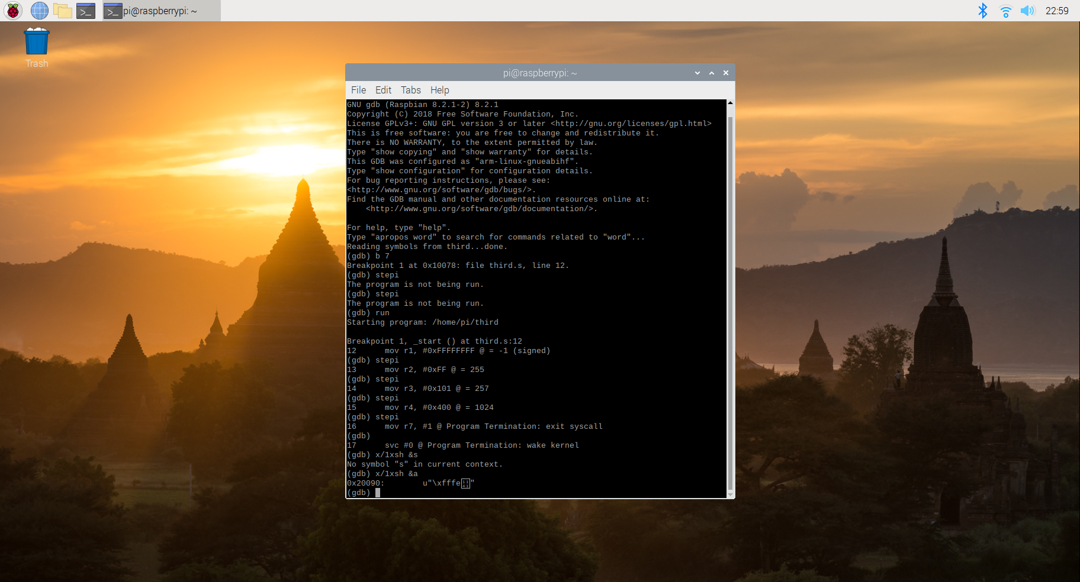

**Part 2: Calculate the expressions**

We then began Part 2 where we created, assembled, linked, ran, and debugged our own program which calculated the expression: Register = val2 + 3 + val3 – val1, where val1=-60, val2=11, and val3=16. As in Part 1, we composed the program through the terminal with nano text editor, before assembling it. After assembly, we linked the program to create the executable file and ran that file.

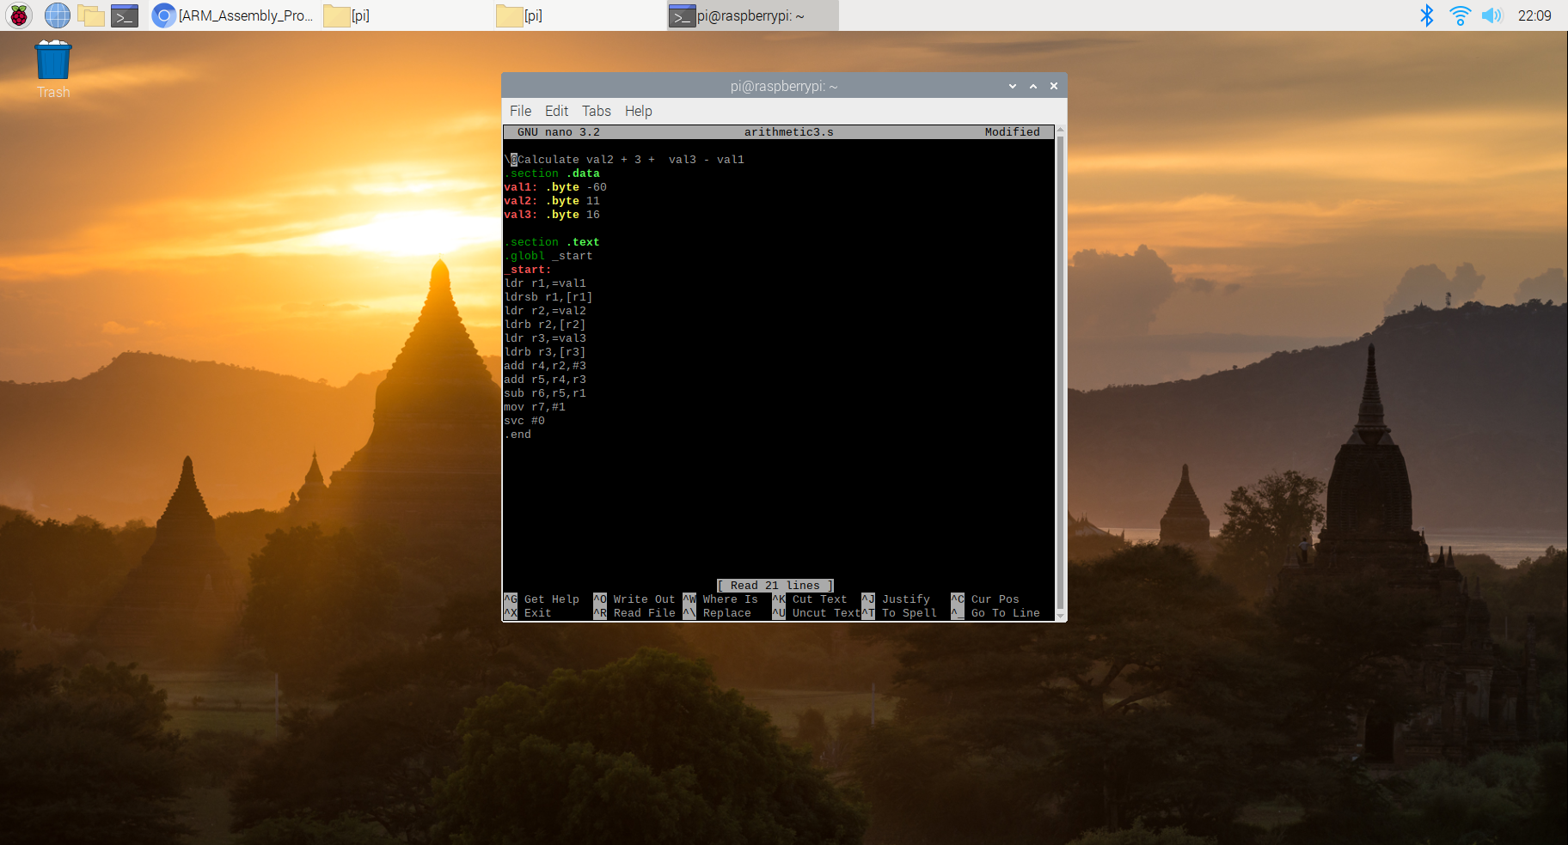

We used the GNU Debugger to get a better idea of how our program was functioning. We did so by following the steps laid out when executing our Second Program: setting a breakpoint, running the debugger, and then executing instructions step-by-step using the “stepi” command. before assembling it. After assembly, we linked the program to create the executable file and ran that file.

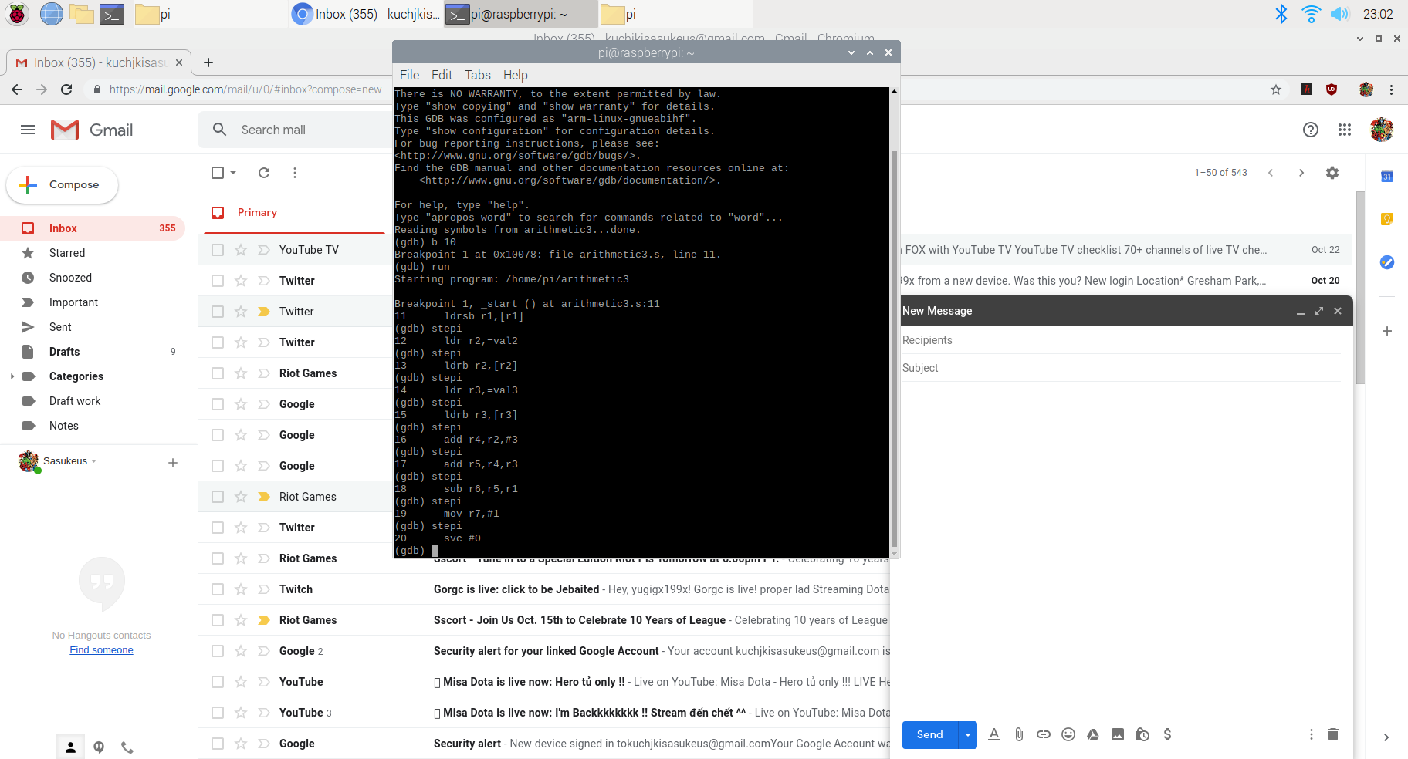

As with before, we were not able to “see” the program at work when it was first executed, so we used the GNU Debugger to get a better idea of how our program was functioning. We did so by following the steps laid out when executing our third Program: setting a breakpoint, running the debugger, and then executing instructions step-by-step using the “stepi” command. Comparing the values stored in the register and memory, we could see that each of the values were expected.

Checking values in the register: The values in the registers are the same with the value we assign and the value we need to compute: val2 + 3 + val3 -val1 = 11 + 3 + 16 – (-60) = 90. The value of val1 is FFFFFFC4 because C4 is a negative number (11000100) and the system extend according to the most significant bit. That’s why there is FFFFFF before C4.

r1 = val1 = FFFFFFC4 = -60; r2 = val2 = 11; r3 = val3 =16; r4 = r2 +3 = 14; r5 =r4 + r3 = 30; r6 = r5-r1 = 90

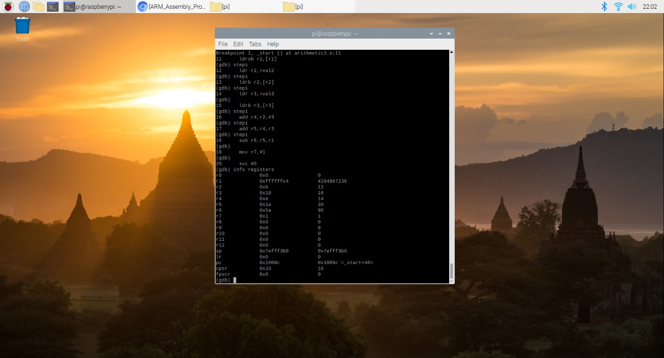

Checking values in the memory: The values in the memory are as expected, val1 = c4, val2 =0b, val3 =10 which in decimal is -60, 11 and 16.

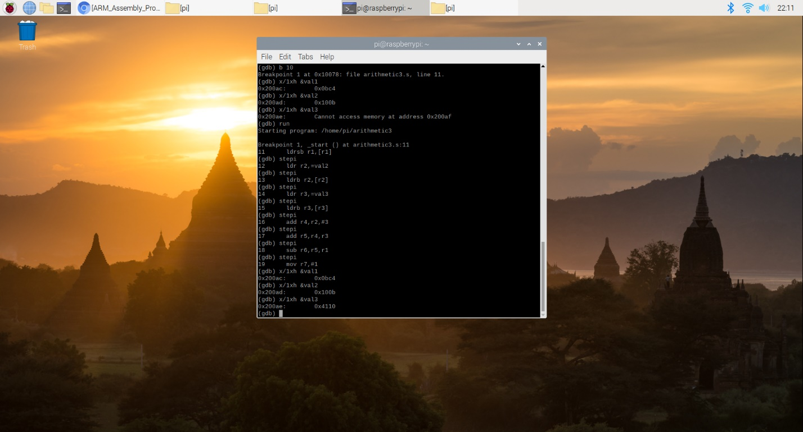

Negative flags value: Since CPSR return 00000010 in hexadecimal, the negative flags is the 31 bits of the value and it equals to 0, which is true because our result is not a negative number.

